Sri Lanka Institute of Information Technology



Assignment 1

Y1S2/23/MTR/Gr02

Online Dry Cleaning and Laundry Services.

**Internet and Web Technologies – IT1100**

B.Sc. (Hons) in Information Technology

**Group Details**

Group Number: Y1S2/23/MTR/Gr02

Project Title: Online Dry Cleaning and Laundry Services.

|  |  |  |  |  |
| --- | --- | --- | --- | --- |
|  | **Student ID** | **Student Name** | **Email** | **Contact Number** |
| 1 | IT22253958 | W.P.R. Nethmina | IT22253958@my.sliit.lk | 703318808 |
| 2 | IT22296078 | Sarithmal K.D | IT22296078@my.sliit.lk | 788724258 |
| 3 | IT22226532 | D.V.D Hashan | IT22226532@my.sliit.lk | 741750500 |
| 4 | IT22635952 | Abeywickrama A.S. | IT22635952@my.sliit.lk | 779195607 |
| 5 | IT22244352 | Hewahalpage | IT22244352@my.sliit.lk | 760702357 |
| 6 | It22371522 | G.H.P Iroshan | It22371522@my.sliit.lk | 719366028 |

# **Introduction**

In an ever-busy world where time is of the essence, the Laundry and Dry-Cleaning System emerges as a reliable solution to meet the pressing needs of individuals and households. This comprehensive system is designed to streamline and enhance the laundry and dry-cleaning experience for all stakeholders involved. With five key actors at the forefront, including Unregistered Customers, Registered Customers, Managers, Administrators, Banks, Dry Cleaners, and Marketing Managers, this system represents a harmonious blend of technology and efficiency.

**Unregistered Customers** are the initial point of entry, representing those who seek laundry and dry-cleaning services without a prior account. Through this system, they gain easy access to top-notch services, transforming a mundane chore into a hassle-free experience.

**Registered Customers** benefit from a personalized and user-friendly platform, where they can create accounts, track orders, and access exclusive promotions. This segment enjoys convenience and loyalty rewards while entrusting their laundry needs to the system.

**Managers** play a pivotal role in maintaining the seamless operation of the system. They oversee the day-to-day processes, ensuring quality control, timely deliveries, and exceptional customer service. Managers are the linchpin of this laundry and dry-cleaning ecosystem.

**Administrators** hold the keys to system management, overseeing user accounts, handling disputes, and maintaining the overall integrity of the platform. Their role ensures that all aspects of the system run smoothly and securely.

**Banks** play a crucial role in facilitating transactions, ensuring a secure and convenient payment process for customers. This partnership with financial institutions guarantees a seamless financial experience within the system.

**Dry Cleaners** are the backbone of this system, providing the necessary laundry and dry-cleaning services with utmost care and expertise. Their commitment to quality and efficiency is integral to the success of this ecosystem.

**Marketing Managers** drive growth and expansion, devising strategies to attract new customers and retain existing ones. Through targeted campaigns and promotions, they ensure that the system thrives in a competitive market.

Together, these actors form the Laundry and Dry-Cleaning System—a comprehensive solution that not only simplifies the laundry process but also adds value to the lives of its users. With user-friendliness, efficiency, and customer satisfaction at its core, this system aims to revolutionize the way we approach laundry and dry cleaning in our fast-paced world. Welcome to a new era of convenience and quality in laundry services.

# **Personas**

* 1st Persona - Unregistered User - Register to the System

**Alex Andrea**

Motivation is to learn more about registration and easy, efficient dry cleaning and laundry service.

“**Looking for Good Laundry Service. Sign Up for Good Benefits!”**

Age: 20

Work: Computer Analysts

Family: Married

Location: New York, USA



Technical Ability

Has a general knowledge about how the system works and interactions. If any problem arises know how to contact System admin.

Goals

* Register to the Laundry website.
* Fulfil their Laundry Requirements.
* To experience Discounts and new Promotions
* 2nd Persona - Registered User **–** User login to the web site

**Joe Norris**

Motivation is to get a quality Dry cleaning and laundry service from the Institute.

Goals

* To get cleaned and Stainless clothes.
* Fulfil the Service at the desired time and with minimum cost.

Technical Ability

Has a general technical knowledge about accessing websites and operate mobile devises.

“**Looking for Good Laundry Service. Sign In for Good Benefits!”**

Age: 23

Work: Businessman

Family: Single

Location: Los Angeles, USA



* 3rd Persona - Manager **–** Manage Employees and Overall Process

**John Fernando**

Goals

* processing all customer orders Accurately and on time.
* Provide Services without Interruptions.
* Pay Salaries on time.

Motivations are to offer committed Service for business by fulfilling every requirement for customers with their cleaned garments with proper condition and for employees with their safe working space.

Technical Ability

Has a good knowledge about controlling web site and making changes.

“**Looking for Good Laundry Service to manage and develop!”**

Age: 53

Work: Manager

Family: Married

Location: London, UK

* 4th Persona - Dry Cleaner – Cleaning and drying clothes

**Nipun Silva**

Age: 22

Work: Technician

Family: Married

Location: Colombo, Sri Lanka

Technical Ability

Operating dry cleaning and laundry equipment, Customer service skills,

Stain removal techniques.

Goals

* Valuing professionalism and providing opportunities for professional development.
* To receive a safe work environment.
* Work in a recognized company.

“**Looking for Good Laundry Service to work hard.**



Motivations are to find a dry cleaner job that offers stability, growth, opportunities, and a competitive salary.

* 5th Persona - Administrator – Manage Database and User Accounts

**Jessica Rodriguez**

Motivations are to complete task within a simple process, have a user-friendly GUI, manage databases with simple steps.

Technical Ability

* Well Experienced System Admin

Goals

* To maintain databases and manage user properly.
* Generate reports according to the services.

“**Want to manage operations with the web application in efficient manner.”**

Age: 32

Work: Software Engineer

Family: Single

Location: Sydney, Australia.

* 6th Persona - Dry Cleaner – Get the Salary

**Rizky Muhammad**

Motivation is to provide a good service to the customers and ensure the cleanliness and safety of the laundry.

Technical Ability

Ability to operate dry cleaning and laundry machinery.

Goals

* Maintain a proper Customer Satisfaction
* To receive more bonuses.

“**Looking for Good Laundry Service to work hard.**

Age: 28

Work: Dry Cleaner

Family: Single

Location: Colomo, Sri Lanka

# **User Journeys**

* Persona - Register for the system.
* User Journey-Register and Login

Open browser and Search “www.Clothes Gallery.com”

Home Page

Unregistered User

Fill Sign Up Form

Click on “Sign Up”

button

Registration

page

Confirm OTP

For recovery phone number

Confirm recovery email by log in to the email account.

View email for account

recovery

Enter Username and Password

Confirm New User Registration

Go to Sign in Button

Log in to the Site.

* Persona - Login to the web site
* User Journey - User login

Home Page

Open browser and search on search bar

Registered User

Log in to the System

Enter Username and Password other details.

Click on the log in Button.

* Persona – Management
* User Journey – Manage Customer Orders

Log in to the system

By using credentials

Browse Website

Manager

If payments are correct confirm orders.

Check whether payments are correct.

View pending orders.

Direct orders to cleaners.

* Persona – Contact Support
* User Journey – Contact Us

Go to the Homepage

Browse website.

Registered User

Log in to the System.

Enter username and Password.

Click Sign in button.

Submit

Enter detailed message about the question.

Go to Contact Us

page

* Persona – Online request for Order
* User Journey – Online request for Order

Home page

Browse the Site.

Registered User

Make Payments

Choose a Suitable service

or services

Go to Services tab in Navigation bar.

Send email about Order,

Submit order.

* Persona – Manage Database and User Accounts
* User Journey – Manage Database and User Accounts

Administrator

Home Page

Browse website.

* Update Database
* Check Orders
* Add and remove staff accounts.
* Deactivate User Accounts
* Generate Reports

Log in to admin account.

Log in Using Admin Credentials

Complete the task.

# **Wire Frames**

* Home Page

* Registration Page

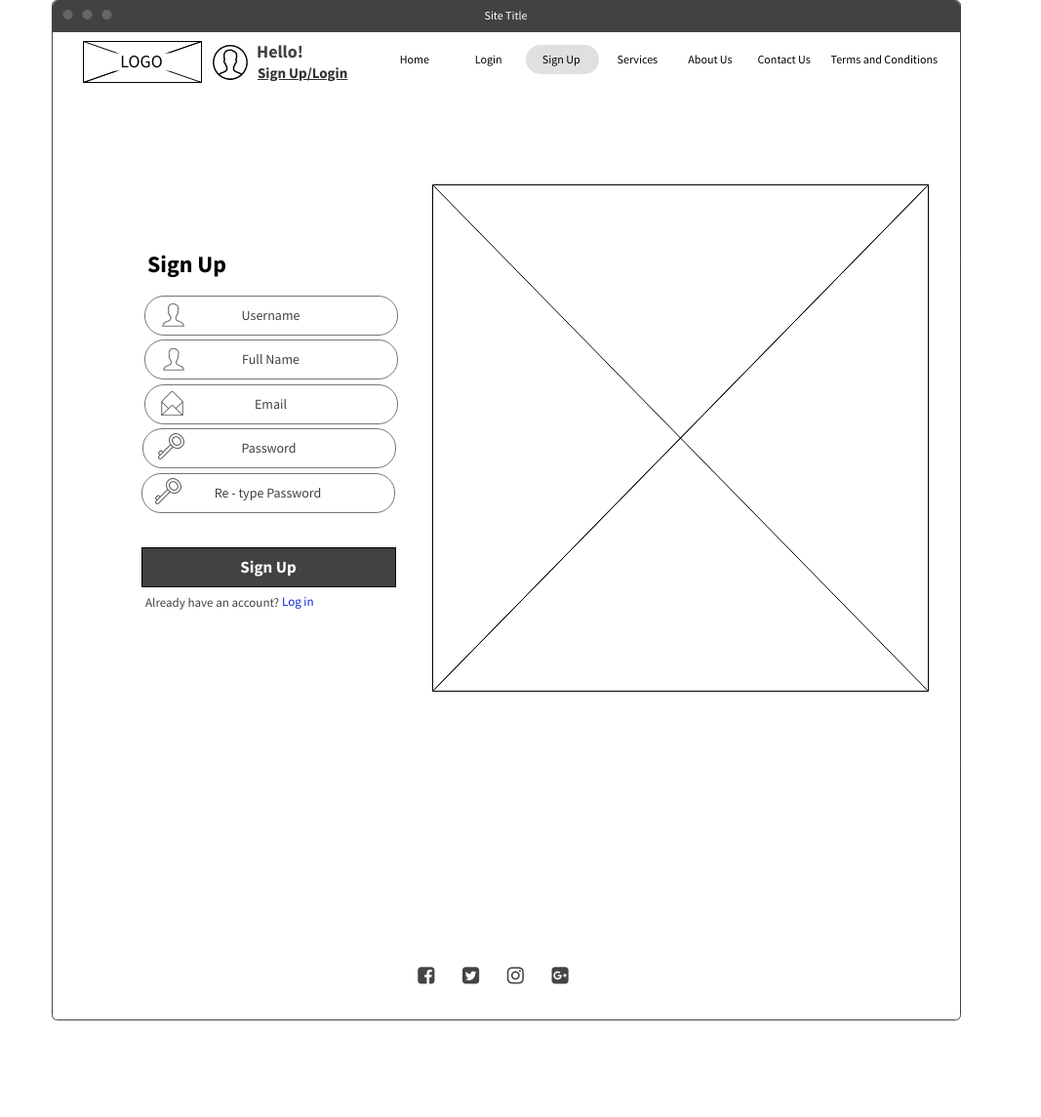

* Login Page

* Contact Us Page

* User Account Page

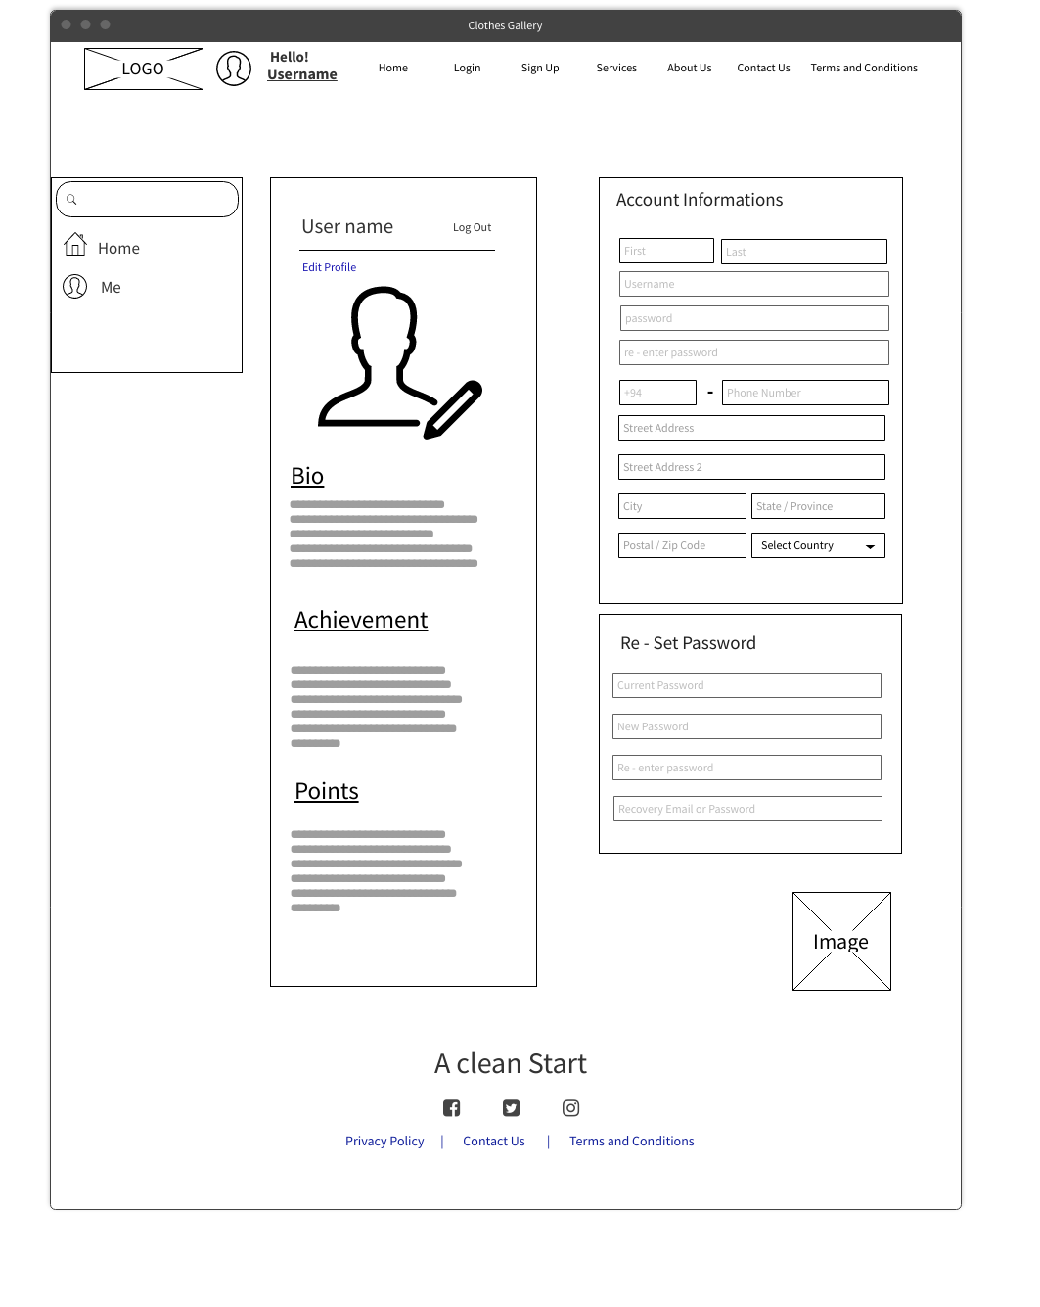

* Our Services Page

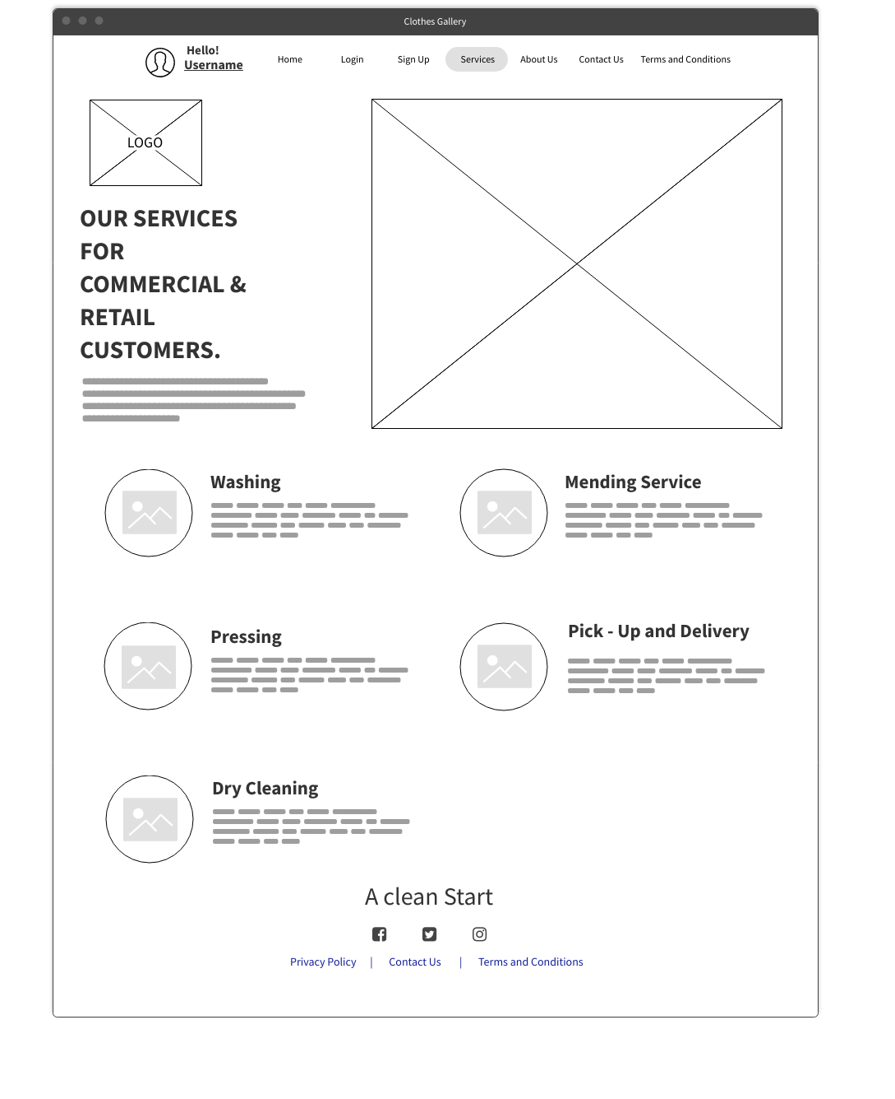

* Home Delivery Page

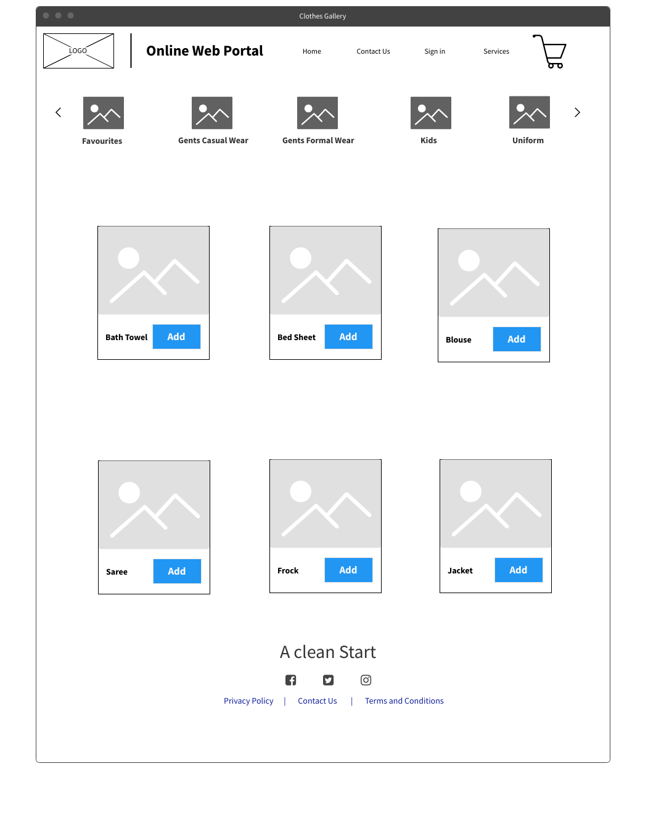

* Our Outlets Page

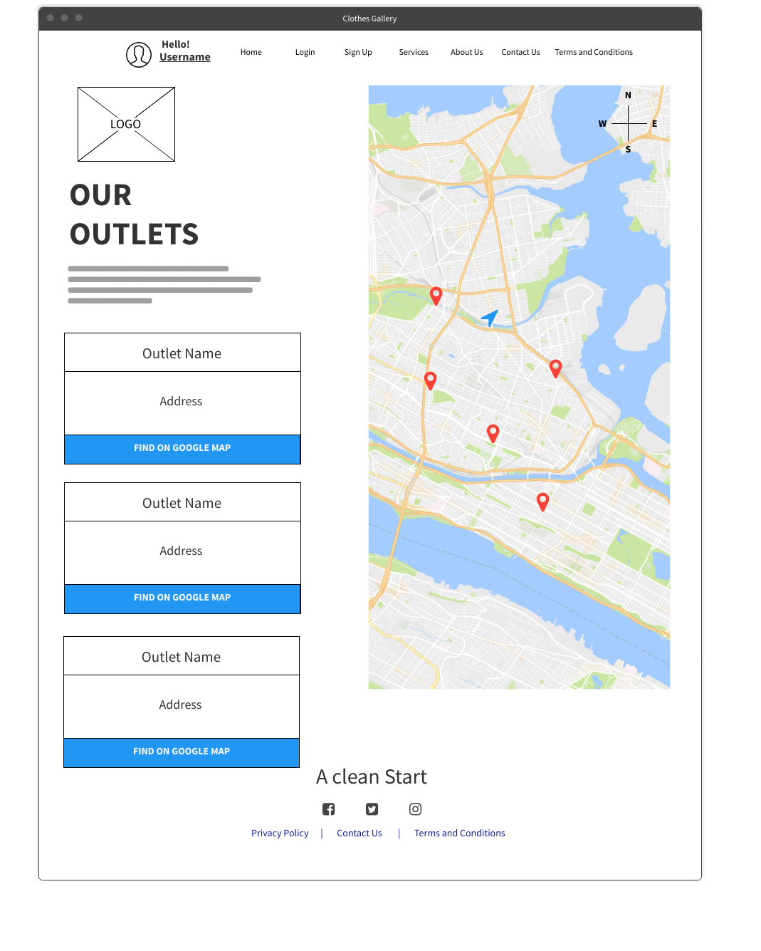

* Administrator Page

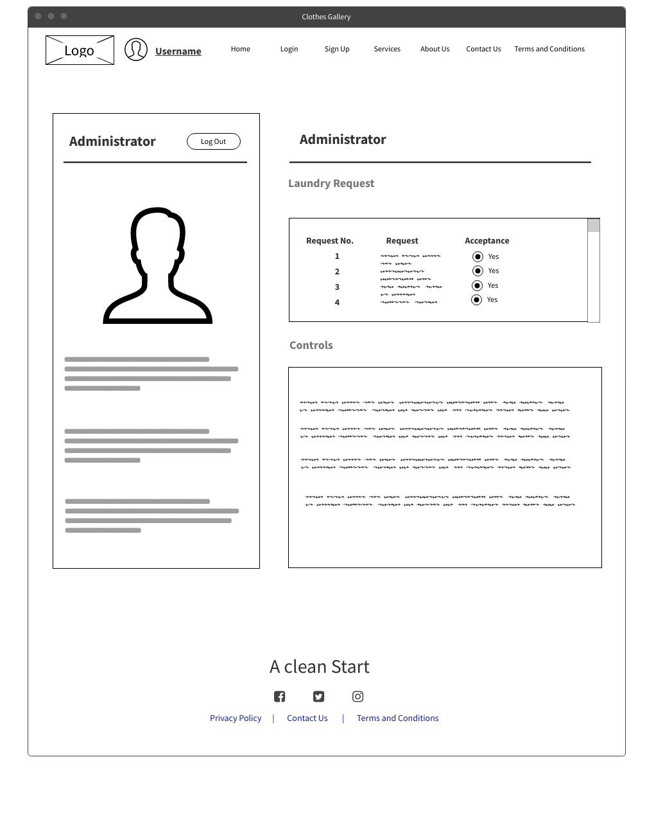

* About Us Page

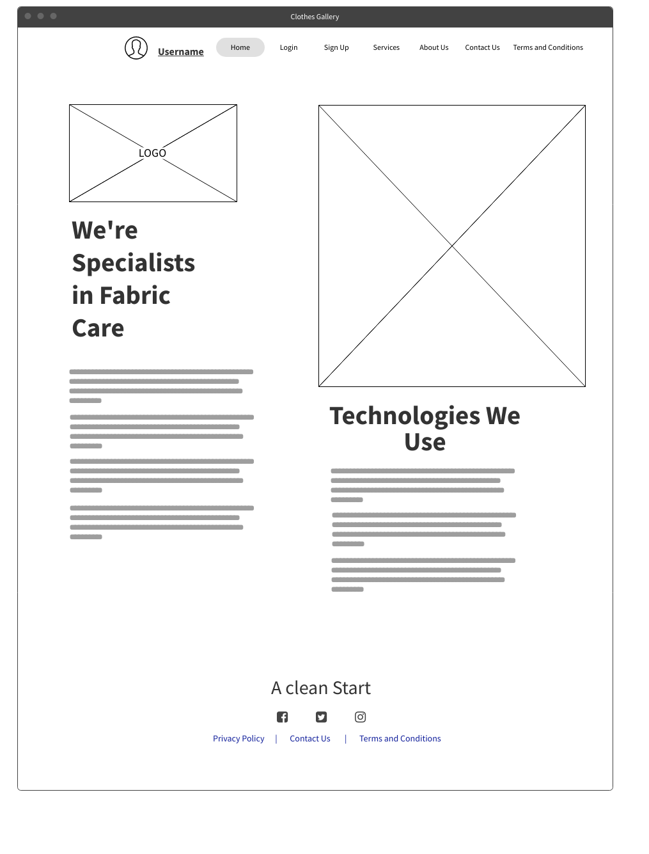

* Privacy Policy Page

* Terms and Conditions Page

# **Individual Contribution**

|  |  |  |  |
| --- | --- | --- | --- |
|  | **Student ID** | **Student Name** | **Individual Contribution** |
| 1 | IT22253958 | W.P.R. Nethmina | * Persona: Unregistered User. * User Journey: Register and Login. * Wireframe: Homepage, Login Page. |
| 2 | IT22296078 | Sarithmal K.D | * Persona: Administrator. * User Journey: User Login. * Wireframe: Sign in page, Contact us Page |
| 3 | IT22226532 | D.V.D Hashan | * Persona: Dry Cleaner * User Journey: Manage Customer Orders. * Wireframe: User Account Page, Our Services page |
| 4 | IT22635952 | Abeywickrama A.S. | * Persona: Registered User. * User Journey: Contact Us. * Wireframe: Home Delivery page, Outlet Page |
| 5 | IT22244352 | Hewahalpage | * Persona: Manager. * User Journey: Online Request for order. * Wireframe: Administrator page, About Us page |
| 6 | IT22371522 | G.H.P Iroshan | * Persona: Dry Cleaner * User Journey: Manage Database & User Accounts. * Wireframe: Privacy Policy Page, Terms and Conditions Page |